Template for Evidence(s)
SAMPLE
UI GreenMetric Questionnaire

University : ...
Country : ...
Web Address : …

[1] Setting and Infrastructure (SI)

[1.16] Security and safety facilites (SI.6)

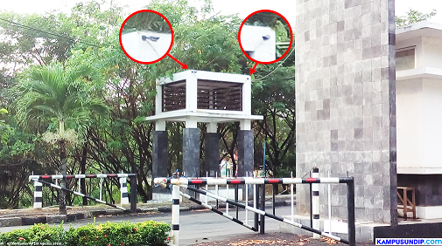 |  | 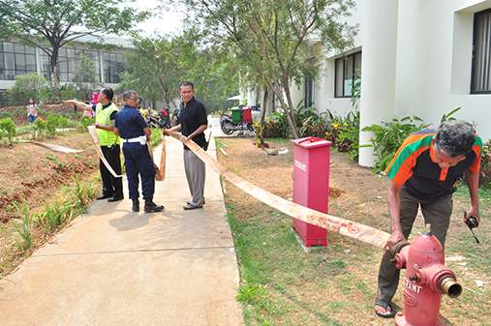
- CCTV in entrance (Universitas Diponegoro, Indonesia) | - Fire Hidrant (Universitas Indonesia, Indonesia)

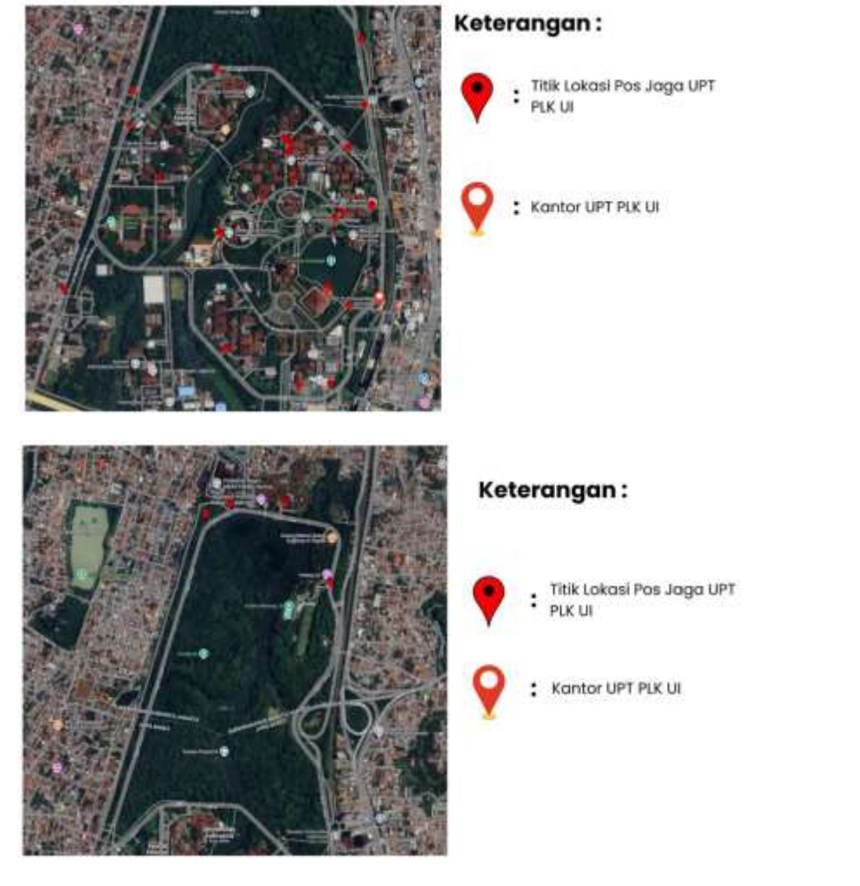

Description:
(Please describe the Security and safety facilites in your campus. The following is an example of the description. You can describe more related items if needed.)

The evidence provided may also include maps showing the location, area size, or distribution of facilities relevant to the indicators

- CCTV at Universitas Diponegoro’s gate
- Fire Hidrant at Vokasi Universitas Indonesia

Additional evidence link (i.e., for videos, more images, or other files that are not included in this file):
- https://vokasi.ui.ac.id/web/pelatihan-k3-simulasi-dan-pelatihan-pemadaman-kebakaran/

